A
Book Report
on
Ruby on Rails Tutorial (Rails 5)

Chapter 1 From zero to deploy
- Introduction
Ruby on Rails (or just “Rails” for short) is a web development framework written in the Ruby programming language.
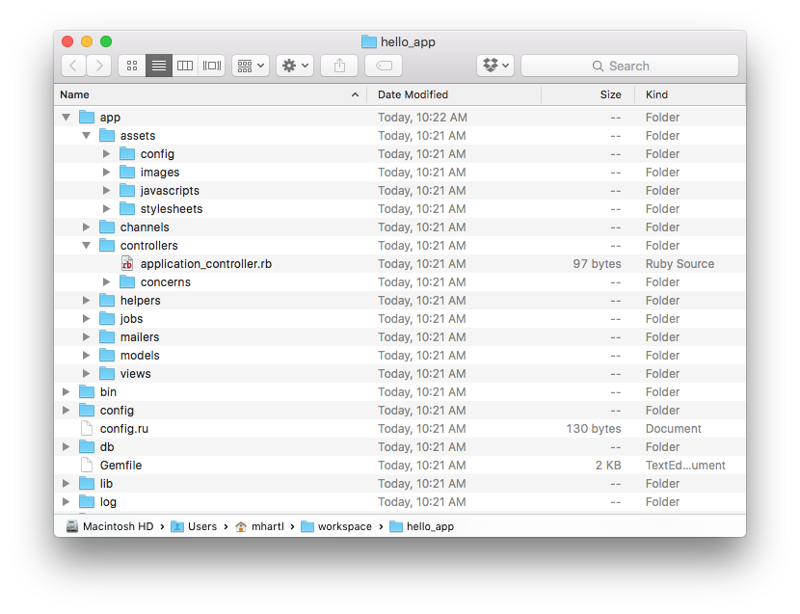
Figure 1.1: The directory structure for a newly created Rails app.

File/Directory Purpose
app/ Core application (app) code, including models, views, controllers, and helpers
app/assets Applications assets such as cascading style sheets (CSS), JavaScript files, and images
bin/ Binary executable files
config/ Application configuration
db/ Database files
doc/ Documentation for the application
lib/ Library modules
lib/assets Library assets such as cascading style sheets (CSS), JavaScript files, and images
log/ Application log file
public/ Data accessible to the public (e.g., via web browsers), such as error pages
bin/rails A program for generating code, opening console sessions, or starting a local server
test/ Application tests
tmp/ Temporary files
vendor/ Third-party code such as plugins and gems
vendor/assets Third-party assets such as cascading style sheets (CSS), JavaScript files, and images
README.md A brief description of the application
Rake files Utility tasks available via the rake command
Gem files Gem requirements for this app
Gem files.lock A list of gems used to ensure that all copies of the app use the same gem versions
config.ru A configuration files for Rack middle ware
.gitignore Patterns for files that should be ignored by Git
There are two ways to specify gem version
1. gem 'uglifier', '>= 1.3.0'
This installs the latest version of the uglifier gem (which handles file compression for the asset pipeline) as long as it’s greater than or equal to version 1.3.0—even if it’s, say, version 7.2.
2. gem 'coffee-rails', '~> 4.0.0’
This installs the gem coffee-rails as long as it’s newer than version 4.0.0 and not newer than 4.1. In other words, the >= notation always installs the latest gem, whereas the ~> 4.0.0 notation only installs updated gems where the last digit differs (e.g., from 4.0.0 to 4.0.1), but the digits before that releases (e.g., from 4.0 to 4.1).
Onces you place the contain in the i.e. gem’s in the Gemfile then run Bundle install to install the Gem in the current project.
$ cd hello_app/
$ bundle install
Fetching source index for https://rubygems.org/
.
.
.

rails server
This command start the rails server. The default server started on the command is Puma. And default port is 3000. we can change the server and also the port of the server.
$ cd ~/environment/hello_app/
$ rails server
=> Booting Puma
=> Rails application starting on http://localhost:3000
=> Run `rails server -h` for more startup options
=> Ctrl-C to shutdown server

To change the port and server we have to add some more information to the rails server command

$ cd ~/environment/hello_app/
$ rails server webrick -p 3001

=> Booting webrick
=> Rails application starting on http://localhost:3001
=> Run `rails server -h` for more startup options
=> Ctrl-C to shutdown server

Model View Controller

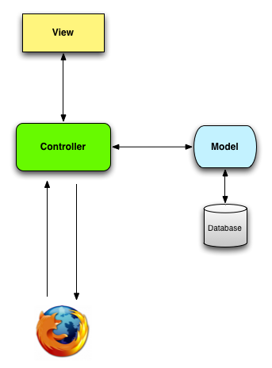

fig 1.2: A schematic representation of the model-view-controller (MVC) architecture.
The standard Rails structure has model controller and view. The directory app/ has the structure also it contain other folder and files.
When interacting with a Rails application, a browser sends a request, which is received by a webserver and passed on to a Rails controller, which is in charge of what to do next. In some cases, the controller will immediately render a view, which is a template that gets converted to HTML and sent back to the browser. More commonly for dynamic sites, the controller interacts with a model, which is a Ruby object that represents an element of the site (such as a user) and is in charge of communicating with the database. After invoking the model, the controller then renders the view and returns the complete web page to the browser as HTML.

Hello world !
Adding a hello action to the Application controller. app/controllers/application_controller.rb

class ApplicationController < ActionController::Base
protect_from_forgery with: :exception

def hello
render html: "hello, world!"
end
end

In the application_controller.rb file we defined the action index and when the action is called then it renders the html and display Hello, world! The route is also needed to set.

Setting the root route. config/routes.rb

Rails.application.routes.draw do
root 'application#hello'
end

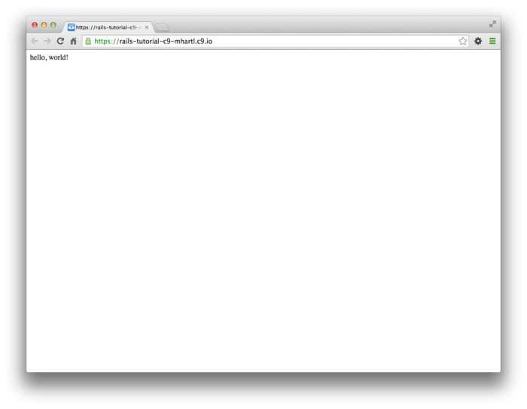

Fig 1.3 viewing “hello world in the browser”

- Version Control with GIT
- planing your code under version controller.
- Version control system allow us to track changes to the project code.
- Before actually sttrating with GIT we have to configure the GIT name and Email.
$ git config --global user.name "Your Name"
$ git config --global user.email “your.email@example.com”
GIT commands
  - Initialize empty git repository in the file system
    - git add -A
  - All all file to the local repository
  - This are in the staging area which contain pending changes to our project
    - git commit -m “Message”
  - Commit all the changes to the local repository.
  - Must be executed before the push command
On the web we must specify the key i.e. ssh key so to generate it we have the following commands
- ssh-keygen
Generates the public and private keys and before generating it asks for the the phrases and location where the generated files to be store.
- To list the generated files
  - ls ~/.ssh
- which displays all the ssh files
  - id_rsa
  - id_rsa.pub
- To display the generates ssh code type
  - cat ~/.ssh.id_rsa.pub

Branch
There is parent repository called as Master Repository. We can create a branch withr using following commands
- git checkout -b modify ReadMe
Which switch from current branch to ReadMe branch.
- git branch
Displays all branch. The branch that preceded with (*) is the current we are working on.
          - Master
          - *modify – ReadMe
Here, all the branch is displayed and current we are working on the modify – ReadMe branch.
Merge
The merge command add all the changes made to a particular branch to the master branch.
- git checkout master
Which switch to the master branch.
To check whether we are on master branch check by doing
- git status
- git merge modify ReadMe
Which adds all the branch files to the master branch.
- git push
Which finally push the committed changes to the repository on the web.
- Heroku
Heroku which is a hosted platform built specifically for deploying Rails and other web applications. Heroku makes deploying Rails applications ridiculously easy—as long as your source code is under version control with Git.
Heroku uses PostgreSQL database which tells us to add the gem in the production in the Gem file shown as below. And add the SQLite in the development section

group :production do
gem 'pg', '0.20.0'
end

group :development, :test do
gem 'sqlite3', '1.3.13'
gem 'byebug', '9.0.6', platform: :mri
end

Th Gemfile would look like as follow:-
source 'https://rubygems.org'

gem 'rails', '5.1.2'
gem 'puma', '3.9.1'
gem 'sass-rails', '5.0.6'
gem 'uglifier', '3.2.0'
gem 'coffee-rails', '4.2.2'
gem 'jquery-rails', '4.3.1'
gem 'turbolinks', '5.0.1'
gem 'jbuilder', '2.7.0'

group :development, :test do
gem 'sqlite3', '1.3.13'
gem 'byebug', '9.0.6', platform: :mri
end

group :development do
gem 'web-console', '3.5.1'
gem 'listen', '3.0.8'
gem 'spring', '2.0.2'
gem 'spring-watcher-listen', '2.0.1'
end

group :production do
gem 'pg', '0.20.0'
end

# Windows does not include zoneinfo files, so bundle the tzinfo-data gem
gem 'tzinfo-data', platforms: [:mingw, :mswin, :x64_mingw, :jruby]

$ bundle install --without production

We are running the bundle install with the flag(-- without production) because we not require the pg gem in development environment but needed at the production environment.
To install the heroku we have to download heroku Toolbelt.
>> sudo apt update
>> sudo apt install snapd
>> sudo sanp install heroku –classic
To check the heroku then run heroku version
Once you’ve verified that the Heroku command-line interface is installed, use the heroku command to log in and add your SSH key:
$ heroku login
$ heroku keys:add
Finally, use the heroku create command to create a place on the Heroku servers for the sample app to live
Creating a new application at Heroku.
$ heroku create [optional application name]
Creating app... done, fathomless-beyond-39164
https://damp-fortress-5769.herokuapp.com/ |
https://git.heroku.com/damp-fortress-5769.git

Heroku deployment, step one
To deploy the application, the first step is to use Git to push the master branch up to Heroku:
$ git push heroku master
To change the remote heroku to already create heroku application we use
$ heroku git:remote -a application name on heroku
then push the git to heroku

Little more about Heroku
- Heroku let you deploy run, manage application written in ruby, nodejs, etc
- Application is collection of source code
  - Source code,
  - A Framework,
  - Dependency description.
Knowing what to execuate
- You dont need to make any changes in order to run into heroku
- If you are running some established framework heroku can figure it out
  - for example:- Ruby on rails => rails server
  - nodejs => the main field of package json
- For other framewrk which is not defined we have to specify explicitly what to execute by a text file called as Procfile.
  - For example:- web:java-jar lib/foobar.jar$port
      - where web => Process type
      - java-jar lib/foobar.jar$port => command to execuate

Chapter 2 A Toy app
In this Section we are using the rails scaffold which generates all the files for us. This will an sample application and the routes is also found here.
$ rails generate scaffold User name:string email:string
invoke active_record
create db/migrate/20160515001017_create_users.rb
create app/models/user.rb
invoke test_unit
create test/models/user_test.rb
create test/fixtures/users.yml
invoke resource_route
route resources :users
invoke scaffold_controller
create app/controllers/users_controller.rb
invoke erb
create app/views/users
create app/views/users/index.html.erb
create app/views/users/edit.html.erb
create app/views/users/show.html.erb
create app/views/users/new.html.erb
create app/views/users/_form.html.erb
invoke test_unit
create test/controllers/users_controller_test.rb
invoke helper
create app/helpers/users_helper.rb
invoke test_unit
invoke jbuilder
create app/views/users/index.json.jbuilder
create app/views/users/show.json.jbuilder
invoke assets
invoke coffee
create app/assets/javascripts/users.coffee
invoke scss
create app/assets/stylesheets/users.scss
invoke scss
create app/assets/stylesheets/scaffolds.scss

This command will create all the necessary file require for the sample appplication.

This is an command which will create migrate file in our application The effect of is to update the database with our new users data model.
$ rails db:migrate
== CreateUsers: migrating ====================================================
-- create_table(:users)
-> 0.0017s
== CreateUsers: migrated (0.0018s) ===========================================

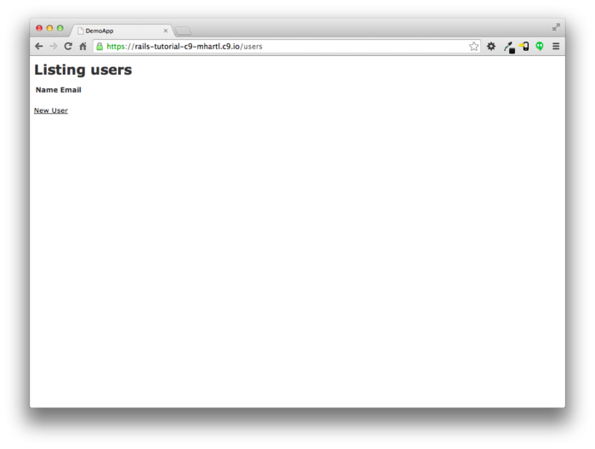
When we run the application we are going to see this as shown below
The index page shows all the user to the application as it is new there is no users right now but, after

Fig 2.1 Index page
adding user we can see them here.

Here after clicking the new user we are directed to entry of new user we have Name and Email field.
After clicking on create user it will create the user.
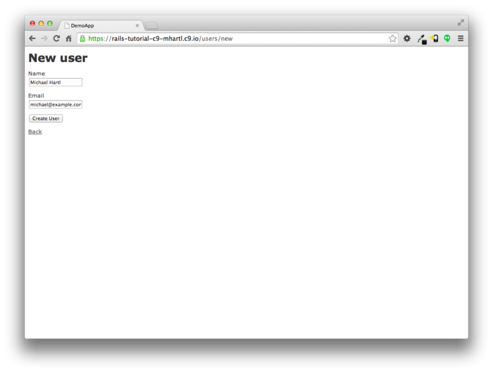
Fig 2.2 Creating User

After the user is created. We are redirected to the index page and here it show the user as it was created previously. Here there are two option to create and destroy user.

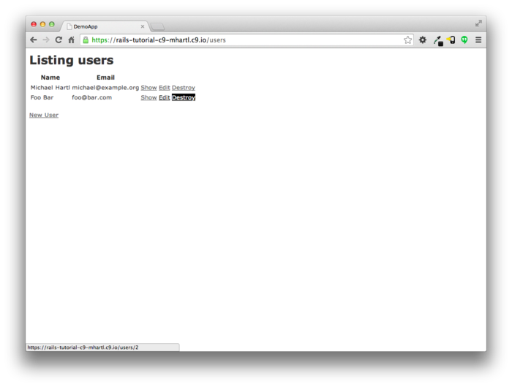
Fig 2.3 Index page

MVC
The browser issues a request for the /users URL.
- Rails routes /users to the index action in the Users controller.
- The index action asks the User model to retrieve all users (User.all).
- The User model pulls all the users from the database.
- The User model returns the list of users to the controller.
- The controller captures the users in the @user variable, which is passed to the index view.
- The view uses embedded Ruby to render the page as HTML.
- The controller passes the HTML back to the browser.

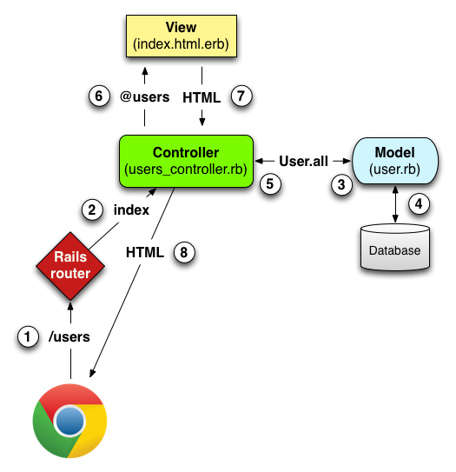

Fig 2.4 MVC details

The scaffold automatically creates the action for the request the User_controller.rb for our application is
The Users controller in schematic form.app/controllers/users_controller.rb
class UsersController < ApplicationController
.
.
.
def index
.
.
.
end

def show
.
.
.
end

def new
.
.
.
end

def edit
.
.
.
end

def create
.
.
.
end

def update
.
.
.
end

def destroy
.
.
.
end
end

The action index,show,edit,new,create,delete,destroy are created after the scaffold command. The index,show,edit,new, are the static pages which action are corresponds to static pages. But, create,delete,destroy these actions don’t typically render pages instead, their main purpose is to modify information about users in the database.

The route for the sample application is as shown below

HTTP request | URL | Action | Purpose
GET | /users | index | page to list all users
GET | /users/1 | show | page to show user with id 1
GET | /users/new | new | page to make a new user
POST | /users | create | create a new user
GET | /users/1/edit | edit | page to edit user with id 1
PATCH | /users/1 | update | update user with id 1
DELETE | /users/1 | destroy | delete user with id 1

Table 1.1 Routes for application.

Chapter 3 Mostly static pages
In this chapter we will create a sample application we are running couples of commands to get start with the application.
>> $ rails _5.1.2_ new sample_app
>> $ bundle install --without production
>> $ bundle update
We are also modifying controllers and routes as follows

Adding a hello action to the Application controller.app/controllers/application_controller.rb
class ApplicationController < ActionController::Base
protect_from_forgery with: :exception

def hello
render html: "hello, world!"
end
end

Setting the root route.config/routes.rb
Rails.application.routes.draw do
root 'application#hello'
end

Generating the Static Pages
$ rails generate controller StaticPages home help
create app/controllers/static_pages_controller.rb
route get 'static_pages/help'
route get 'static_pages/home'
invoke erb
create app/views/static_pages
create app/views/static_pages/home.html.erb
create app/views/static_pages/help.html.erb
invoke test_unit
create test/controllers/static_pages_controller_test.rb
invoke helper
create app/helpers/static_pages_helper.rb
invoke test_unit
invoke assets
invoke coffee
create app/assets/javascripts/static_pages.coffee
invoke scss
create app/assets/stylesheets/static_pages.scss

Some of the rails shortcuts are as follow
Full command | Shortcut
$ rails server | $ rails s
$ rails console | $ rails c
$ rails generate | $ rails g
$ rails test | $ rails t
$ bundle install | $ bundle
Table 3.1: Some Rails shortcuts.
Here, we are making some changes to the home and help view pages as shown below
Custom HTML for the Home page.app/views/static_pages/home.html.erb
<h1>Sample App</h1>
<p>
This is the home page for the
<a href="http://www.railstutorial.org/">Ruby on Rails Tutorial</a>
sample application.
</p>

Custom HTML for the Help page.app/views/static_pages/help.html.erb
<h1>Help</h1>
<p>
Get help on the Ruby on Rails Tutorial at the
<a href="http://www.railstutorial.org/help">Rails Tutorial help page</a>.
To get help on this sample app, see the
<a href="http://www.railstutorial.org/book"><em>Ruby on Rails Tutorial</em>
book</a>.
</p>

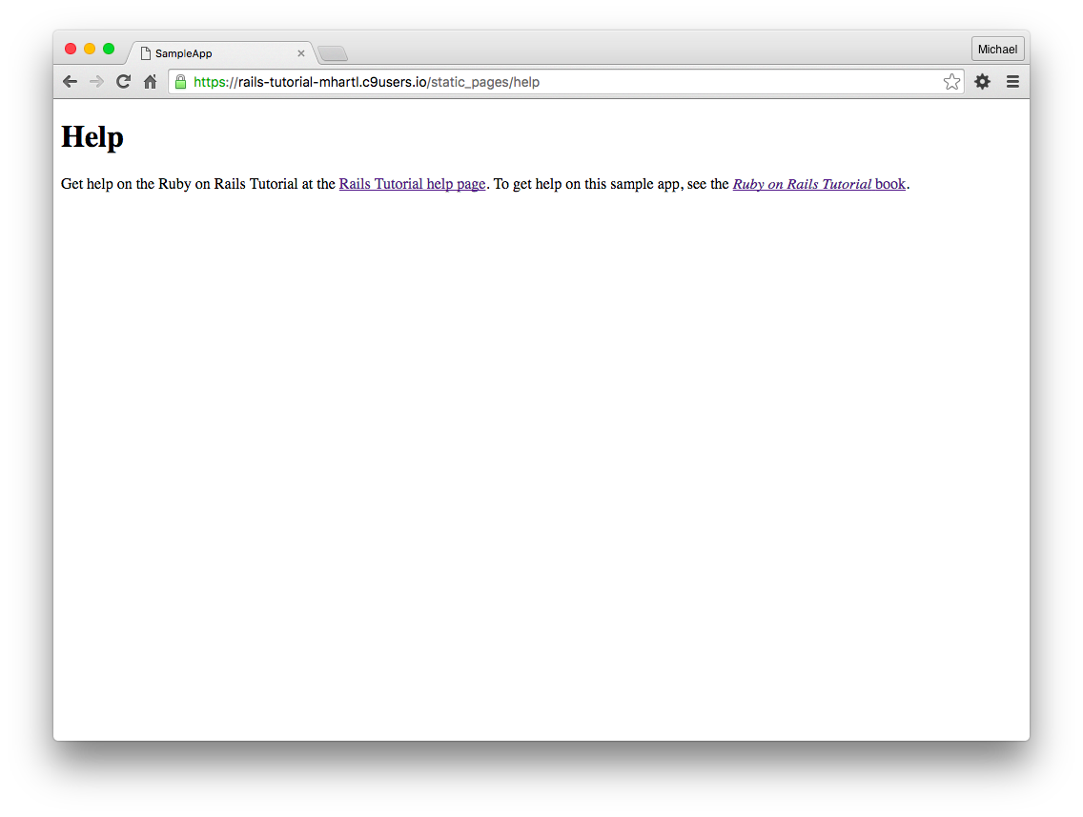
Fig 2.5 Custom Help page

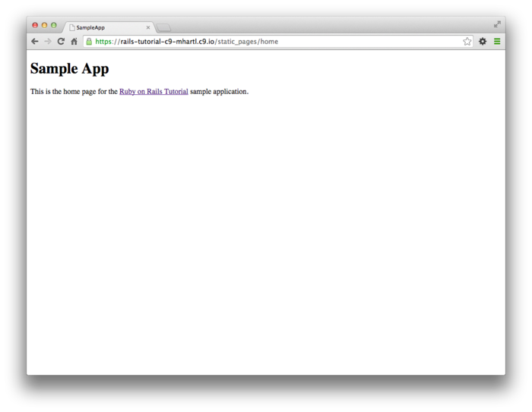
Fig 2.6 Custom Home page

Chapter no 4 Rails-flavored Ruby
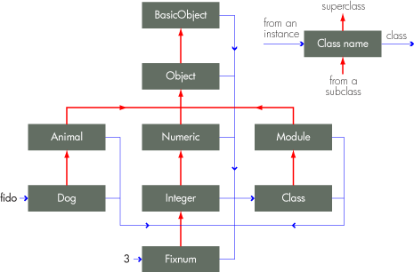
Everything in ruby is object. Ruby is Dynamic and object oriented language.
To start ruby, we have command $ Rails console which start IRB .i.e. Interactive Ruby
Fig 4.1 Understanding ruby
For example:-
a = 1
a.class => Integer
a.class.superclass => Numeric
a.class.superclass.superclass => Object
a.class.superclass.superclass.superclass => Basic Object

Comments
In ruby we can give comment with pound sign (#)
for example:-

$ rails console
>> 17 + 42 # Integer addition
=> 59

String
In example below, there is empty string and non empty string.
$ rails console
>> "" # An empty string
=> ""
>> "foo" # A nonempty string
=> "foo"

We can concatenate the string by using “+” as follow
>> "foo" + "bar" # String concatenation
=> "foobar"

We can pass the method for the object in the we create as follows
>> "foobar".length # Passing the "length" message to a string
=> 6

>> "foobar".empty?
=> false
>> "".empty?
=> true

Other data structure
An array is just a list of elements in a particular order.
For example:- >>a[42, 18, 10]
=>[42, 18, 10]
>>a[0]
=>42
>>a[1]
=>18
>>a[2]
=>10
>>a[-1]
=>10
>>a[-2]
=>18
When we use “bang” methods it make changes to the itself
for example:-
>> a[42,8,15,10]
=> [42,8,15,10]
>> a.sort!
=> [8,10,15,42]
>> a
=> [8,10,15,42]
here the sort has been made on the object itself i.e. a. if we have not used the bang methods then it will make a copy of sorted array.
Blocks
Blocks are the powerful feature in ruby. The following example is of the block in ruby
>> (1..5).each { |i| puts 2 * i }
2
4
6
8
10
=> 1..5
Here, code calls for the each method in the ranges(1..5) and passes the block {|i| puts 2*i}. The vertical bars around the variable is the syntax for a vairable and its up to the method to know what to do with the block.
Hashes
Hashes are essentially arrays that aren’t limited to integer indices.
>> user = {} # {} is an empty hash.
=> {}
>> user["first_name"] = "Michael" # Key "first_name", value "Michael"
=> "Michael"
>> user["last_name"] = "Hartl" # Key "last_name", value "Hartl"
=> "Hartl"
>> user["first_name"] # Element access is like arrays.
=> "Michael"
>> user # A literal representation of the hash
=> {"last_name"=>"Hartl", "first_name"=>"Michael"}

Chapter 5 Filling the layout
In this chapter we are working with respect to the style sheet to make our application more effective. We are using the bootstrap gem for the styling the web-pages.
Assets Directive
app/assets => assets specific to the application
lib/assets => assets for library written by the developer team
vendor/assets =>assets from third party
To use the Bootstraps we have to add dependency to the Gemfile of our project.
Adding the bootstrap

gem ‘bootstrap-saas’,’3.3.7’
.
.
.
.

Then run bundle install command to get the dependency include in the project.
We can also use the custom CSS style to style our html pages. We can use the app/assests/stylesheet to store our css and use in the html pages for styling.
But, as we are using the bootstrap we are including the bootstrap file like
@import “bootstrap-sprocket”
@import “bootstrap”
this include all the bootscrap framework
for example :-
h1{
font-size:10px;
margin-top: 5px;
font-family:chiller;
}

Assets Pipeline
Assets pipeline is framework to concatenate and minify or compress JS and CSS assests also add ability to write in other langauge and preprocessor
Ex:- rails new app_name – skip sprockets
rails automatically adds the saas-rails,coffee-rails,uglifier gem to you gemfile. If we avoid above line. The above line do not add the saas-rails,coffee-rails,uglifier gem to gemfile.
Uglifier gem is used for the compression for the assests pipeline.
Feature of Assets pipeline
concatenate assets
which reduces the no. of request that a browser makes to render a web pages.
For ex – sprockets concatenate all .js file to master.js file and all .css file into master.css file.
Assets minfy
for css the whitespaces and comments are removed
for js,more complex process are applied
Manifest file
Used to tell how to combine all file into one single file
*=require_tree – ensures that all CSS files in the app/assests/stylesheets are included in application CSS
*=require_self – specifies where in loading sequences the css in application.css

Chapter 6 Modeling users
In this chapter I have learned about the model in rails. We generate model by following commands.
rails generate model User name:string email:string
this generate the model form our application which is used making the data persist to the database. The solution to make the data persist to the database is to use the Active Record library. Active Record comes with the method for creating saving and finding data object without having to use the Structured Query Language
Migration
It allows to alter the database according to the changes. For above model the migration file would look like
class CreateUsers < Activerecord::migration
def change
create_table :user do|t|
t.string :name
t.email :string

t.timestamps
end
end
end

here, t.timestamps is there which creates the two columns in the database called as created_at and updated_at. The table would be like

id | Integers
name | string
email | string
creates_at | datetime
updated_at | datetime
Fig 5.1 User model produced by migration

to make this all changes we run the command as following
$ rails db:migrate
this will give me an development.sqlite3 file in db.

Working with Interactive Ruby
To work with the sq-lite database we will open rails console and enter in the sandbox mode. So, sandbox is mode which will rollback all the change to database after exit
$ rails console – sandbox
>> User.new
=>#<User id:nil, name:nil, email:nil,created_at:nil, update_at:nil>

>>user = User.new(name:”saiprasad”,email:”saiprasaddevare12@gmail.com”)
=>#<User id:nil, name:”saiprasad” email:”saiprasaddevare12@gmail.com”,created_at:nil, update_at:nil>

>>user.save
(0.1ms)SAVEPOINT active record_1
SQL (0.8ms) INSERT INTO “users”(“name”,”email”,”created_at”,”updated_at”) values(?,?,?,?)[[“name”:”saiprasad”],[“email”:”saiprasaddevare12@gmail.com”],[“created_at”,2017-11-23 19:05:28 UTC],[“updated_at”,2017-11-23 19:06:40]]
(0.1ms) RELEASE SAVEPOINT active_record_1
=>true
Find
Active record gives us method to find the objects
User.find(1)
=>#<User id:1, name: “saiprasad” email:”saiprasaddevare12@gmail.com”,created_at:2017-11-23 19:05:28,updated_at: 2017-11-23 19:06:40>
User.find(3)
=>ActiveRecord::RecordNotFound: Couldn’t find User with ID=3
User.find_by(email:”saiprasaddevare12@gmail.com”)
=>#<User id:1, name: “saiprasad” email:”saiprasaddevare12@gmail.com”,created_at:2017-11-23 19:05:28,updated_at: 2017-11-23 19:06:40>

Validating Presences
In the model, our project we define the validating presences , so that we can’t go further until we have put the correct value to the field which is not null.
Ex
class User < ApplicationRecord
validates :name, presences:true
end

Length Validation
This validates regarding to the length so, like password filed should have 8 character minimum
Here, we can use the validate length field.
class User < ApplicationRecord
validates :name, presences:true, length:{maximum: 50}
validates :email, presences:true, length:{maximum: 255}
end

Hashed Password
In the project we have used the hashed password so that if the attacker stole database then he cant get the password as the user . We use has_secure_password method
This method adds following functionality
1.To save hash digest attribute to the database
2.Authentication method that return the user when user is corrrect

